As the founder and Chairman, I would like to welcome you most warmly to Defence in Business, a community of active and former serving members dedicated to fostering networking, mentoring and career opportunities.

No matter if you are an active or former serving member, an organisation looking to attract Defence training and leadership or just an individual interested in connecting with the Defence community, there are a number of ways DiB can add value to you. In essence, we offer you a support structure and provide a platform to create networking and career opportunities. This will enable you to boost your career or business or simply to stay connected with the Defence and business community. At the core, what distinguishes DiB is the shared values and high ethical standards which our members uphold. This really does create a unique bonding and collegiate atmosphere which you'll sense very quickly when you attend one of our events.

For now, I invite you to have a look around and explore the several ways you can connect with DiB and our members:

* The LinkedIn group and DiB Online Community
* Local Networking Events (QLD only)
* Special partner offerings

We aim to enable you to leverage Defence expertise by providing a trusted, collegiate environment that fosters business for the benefit of everyone involved.  I encourage you to be an active part of this community.

Please do not hesitate to contact me to discuss any queries you may have.



**Dr Thomas Triebsees**  
Founder, Chairman  
Defence in Business  
*serving more*

Leadership Team - Board of Directors

|  |  |  |  |  |
| --- | --- | --- | --- | --- |
| Thomas Triebsees |  | **Dr Thomas Triebsees**  Chairman  M 0423 249 680  E [thomas@defenceinbusiness.com](mailto:thomas@defenceinbusiness.com) | alt |  |
| Thomas spent twelve years in the German Army Signal Corps, including two international deployments to Afghanistan and Kosovo. He discharged early 2008 in the rank of Captain and moved straight to Australia. Whilst progressing his career, he has been establishing Defence in Business. His background is Digital, Customer Service and Program Delivery. He holds a Doctorate Natural Sciences from the University of the German Armed Forces in Munich and a Graduate Certificate in Business Administration from the Queensland University of Technology. | |  |

|  |  |  |  |  |
| --- | --- | --- | --- | --- |
| Tim Keeffe |  | **Tim Keeffe**  Director    M 0413 137 992  E [tim.keeffe@defenceinbusiness.com](mailto:brice.pacey@defenceinbusiness.com) | alt |  |
| Tim served in the Australian Army as a Logistics Officer for more than 20 years, enjoying a breadth of experiences including Command at Troop and Sub Unit level, various logistics planning roles, Project Management as well as a variety of instructional postings in both trade and all corps roles. Drawing on that experience Tim established himself as a consultant in 2015, and is now the CEO of Actrua Performance Cultures leading a global team of facilitators and consultants. Tim’s practical experience is amplified by diverse and successful academic achievements including a Bachelor of Arts (Hons), a Masters of Engineering (Hons), graduate qualifications in Logistics, Human Resource Management, Coaching and Public Safety. Tim is also a Graduate of the Australian Institute of Company Directors (AICD). While no longer actively serving, Tim is committed to helping others transition successfully into the business environment. | |  |

|  |  |  |  |  |
| --- | --- | --- | --- | --- |
| Blake Barrett |  | **Blake Barrett**  Director    M 0432 604 124.  E [blake.barrett@defenceinbusiness.com](mailto:blake.barrett@defenceinbusiness.com) | alt |  |
| Blake served in the Royal Australian Air Force for over 28 years as an engineering officer and senior non-commissioned officer. Blake lead project engineering with Unmanned Aerial Targets, F-111, Wedgetail AEW&C, Minor Projects, Technical Airworthiness; and Air Command units in Joint Electronic Warfare Operational Support Unit, and F-111 operational and maintenance units. Post military service, Blake has held roles as a RPDE consultant, Queensland Rail PM, The Smith Family volunteer PM, Parsons Brinkerhoff regional civil engineering team lead, QinetiQ engineering executive, Turner & Townsend Thinc Senior PM & commercial contract manager, and past Queensland Chair of Centre for Engineering Leadership and Management. Blake has professional qualifications in business, engineering and project management, with a GAICD, MBA, MSc, CPPM, BEng, CPEng, Engineering Executive, and honours including a Conspicuous Service Cross. | |  |

# About Us: Defence in Business

Defence in Business (DiB) is a social enterprise aimed at enabling people and organisations to leverage Defence expertise for mutual reward through tailored networking, education and career opportunities. To this extent, DiB is positioned to liaise between Defence, Business and the individual active/former serving members to enable

* The individual to successfully transition between Defence and civilian careers
* Businesses and organisations to network with, meet, secure and develop high quality talent
* The ADF to keep in touch with their personnel for ongoing career opportunities

**DiB Vision**  
Our vision is to be the leading organisation connecting business and those who have served their nation.

# DiB Mission

|  |
| --- |
| “Our mission is to enable ***people*** and ***organisations***  to leverage ***Defence expertise*** for mutual reward  through ***tailored networking***, ***education*** and ***career*** opportunities.” |

## 

## **Why is this relevant**

Servicemen and women put their lives on the line for their country and for every one of us. On deployments worldwide and under adversity, hardship and personal sacrifice, they develop distinctive attitudes and qualities which enable them to:

* Diligently prepare and execute vital plans in complex and global environments.
* Show focus, adaptability and initiative to ensure success during rapid change.
* Consistently deliver top team results in mission critical situations.

Acquiring and leveraging these highly valuable qualities is beneficial for any organisation aiming to exploit competitive advantage.

It is also vital for any ex Defence member in business to be able to fully capitalise on their skills.

That’s where DiB helps - through tailored networking and professional development services.

# Our Objectives

* Provide a highly established international business network based on shared values.
* Advocate the enormous benefits of integrating Defence experience into organisations.
* Enable organisations to easily find, integrate and leverage people with Defence experience.
* Facilitate transition, mentoring and professional development for people with Defence experience.
* Promote in business the strong morals and ethics emphasised by Defence.

# Our Services

DiB currently provides the following core services:

* A national [LinkedIn page](https://www.linkedin.com/groups/1938071/) and [online community](http://www.defenceinbusiness.com/index.php/component/community/frontpage?Itemid=80) to foster online networking and exchange of experiences
* Quarterly[networking events](http://www.defenceinbusiness.com/index.php/component/dtregister/?task=calendar&controller=calendar&showby=0&calview=month&Itemid=224) (Queensland only).
* A tailored Recognition of Prior Learning (RPL) offering
* A [BenchOn partnership](http://www.defenceinbusiness.com/index.php/alldobservices/benchon-partnership) providing free access to its supplier sourcing platform

## **Our History**

Thomas started the organisation in 2009 in Brisbane (then named Defence Officers in Business) after he arrived in Australia, just having discharged from the German Army and looking for work. While doing so, he met many ex-servicemen in business who were in senior / hiring positions and often felt an instant rapport. Thinking back to his time in Afghanistan and Kosovo, where he served with officers from up to 25 nations, he realised that the bonding that is developed (across borders) during the time in the military never really gets lost. So, he started bouncing the idea of organising an informal catch up for drinks. The group had a turn-out of 30 at the first gathering in Brisbane which demonstrated interest so they kept going.  
Over time the team realised that there was a big gap in Australia to fill by connecting the business world with active, transitioning and former service members for the purpose of enabling business and other opportunities. Thomas then set up an Advisory Panel to define the scope for DiB and come up with the vision/mission.  
DiB’s community has since grown to more than 2,000 following our national launch in November 2011.

## **Our Individual Members**

First and foremost we provide a destination for our individual members to network and share experiences. What makes us unique is our

* Shared Defence and business background.
* Strong bonding & collegiate attitude.
* Shared values and high ethical standards.

# DiB's Unique Strategic Position

We build bridges between Defence, the ex Defence community and the business community to the benefit of our members. Unlike Ex Service Organisations (ESO) that mainly deal with health and lifestyle issues, DiB deals with  business and career issues.  We believe in the tremendous value ESO's provide and therefore proactively support their efforts.

# Why Join

|  |  |
| --- | --- |
| **Individuals** Are you active, transitioning or ex Defence? Do you share our values and desire to “serve more” by leveraging your Defence experience in your career outside Defence? We help you;   * Meet like-minded business people in a trusted, collegiate environment. * Open doors to your next client, business partner or employer. | **Organisations** Do you employ ex Defence people, contract to Defence or seek team members with superior qualities? Would you like to connect with the Defence community? We help you;   * Find people with distinctive leadership, resilience, discipline or specialised skills. * Offer tailored products and services to the ex Defence community. |

Recognition of Prior Learning

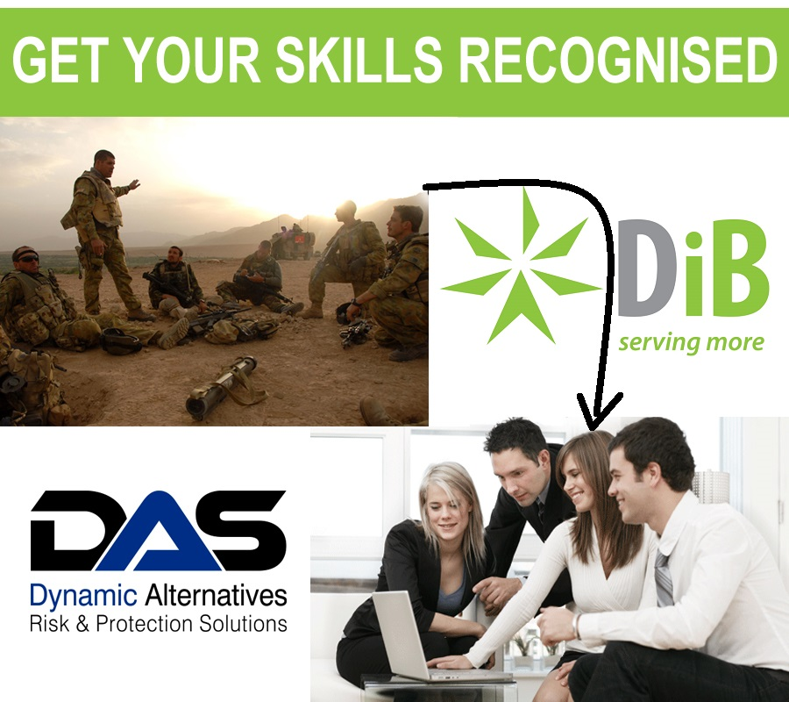

  
  
DiB agrees, that’s why we’re proud to partner with Asset Training Australia (RTO # 31718) to offer our members a unique opportunity to gain Australian nationally recognised qualifications (Certificates, Diplomas and Advanced Diplomas) via Recognition of Prior Learning (RPL).  
  
**What is RPL?**

Recognition of Prior Learning (RPL) is an assessment pathway offered by Registered Training Organisations such as Asset Training Australia for individuals to gain a nationally recognised qualification.

Generally, to achieve a qualification you would undertake a training program followed by an assessment process. The RPL pathway is a substitute for the standard assessment process for individuals who have gained the same knowledge and skills through their experience rather than through a training program. This process recognises that experience can be as valuable as undertaking training. For example, you may have practical experience managing a unit of defence personnel, but no formal qualification in management. Through the RPL process, you could be awarded a Diploma of Leadership & Management.

We understand that people acquire knowledge and skills from other training programs (both accredited and non-accredited), employment within various industries as well as participation in voluntary, social and recreational activities. By documenting and assessing this experience (or prior knowledge), our assessors may be able to align this experience to competencies in the Australian Qualifications Framework.

In cases where an applicant can supply evidence that aligns completely with the requirements of the unit or qualification applied for, Asset Training Australia can issue the relevant Qualification or Statement of Attainment without the candidate requiring further training/assessment.

Download the RPL guide for more information.

Why Through DiB

  
  
DiB have partnered with Asset Training Australia primarily because of their unique capability to offer RPL services to current and former Defence Members. Members seeking to have their service experience count towards their career can truly benefit.  
  
What makes this service unique is that the RPL assessment process for DiB members is conducted by assessors with extensive Defence experience who fully understand your background. This provides the best opportunity for recognising your skills, capabilities and experience to assist in gaining the maximum possible qualifications to improve your career prospects. Most importantly Asset Training Australia's user friendly process saves you time, money and effort because you don’t have to sit through training in areas you have already achieved in your Defence career.  
  
**Qualifications Available**

* Business and administration
* Training and assessment
* Human resources
* Investigative services
* Leadership and management
* Project management
* Security and risk management
* Work health and safety

If you are looking for a different qualification, please let us know and we will be able to direct you to someone who will be able to help.

As a special offer to DiB members, get 50% off your second qualification when you apply for RPL through Asset Training Australia.

So contact us below to get those missing qualifications you probably already have now!

Top of Form

**RPL Enquiry**

Frist Name

Last Name

Phone

Email

City

State

  ACT NSW NT QLD SA TAS VIC WA Other

Defence Background

E.g., Navy, Army, Air Force, Highest rank, Corps or Mustering

RPLs Sought

If you don't know, leave this field blank and we'll contract you to discuss

Short Summary of Experience And Existing Qualifications

If you don't know your qualifications, leave this field blank and we'll contract you to discuss

Please enter the code

Bottom of Form

DiB and BenchOn Partnership

BenchOn is B2B Supplier Sourcing platform that matches businesses idle staff to short-term contracts with reputable companies and Government Agencies. That way businesses can now manage the peaks and troughs of the business cycle like never before with access to the high-quality professionals hidden inside the best companies to support during surges and contracts for their staff who are on the bench in the troughs.

DiB has partnered with BenchOn to provide DiB members with free access to their supplier sourcing platform. This enables companies to save up to 40% on their supplier sourcing costs because its fast with matches occurring within 24hrs, its efficient with no requirement to manually search out companies and it provides you access to the available capacity in across multiple industries.

through the partnership, you will be able accrue points towards DiB Membership with every successful transaction you complete on the platform. Once sufficient point based on the value of the transaction have been acrrued, BenchOn will fund your DiB membership.

Please use the enquiry form below to learn more and receive **your special offer code**:

Top of Form

**DiB BenchOn Partnership Enquiry**

First name

Last name

Organisation

Email

Phone

State

  ACT NSW NT QLD SA TAS VIC WA Other

Bottom of Form